Hackerrank

https://www.hackerrank.com/challenges/the-report/problem
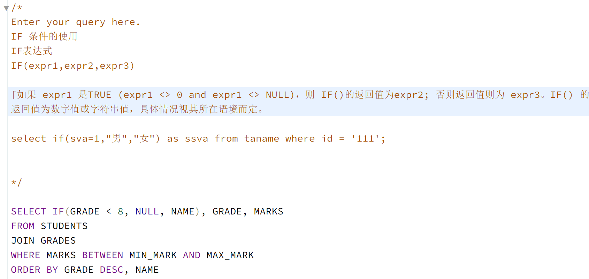

https://www.hackerrank.com/challenges/full-score/problem
关键点：
1. 使用较大的表把他们全部join 起来，
2.开始写where 里面的条件（难点是who achieved full scores == submission.score = difficulty.score）
3.group 同时以hacker_id 和 name 分组 我就卡在这里 having count(s.hacker_id) > 1 超过 1个challenge
4. 排序 中间逗号隔开
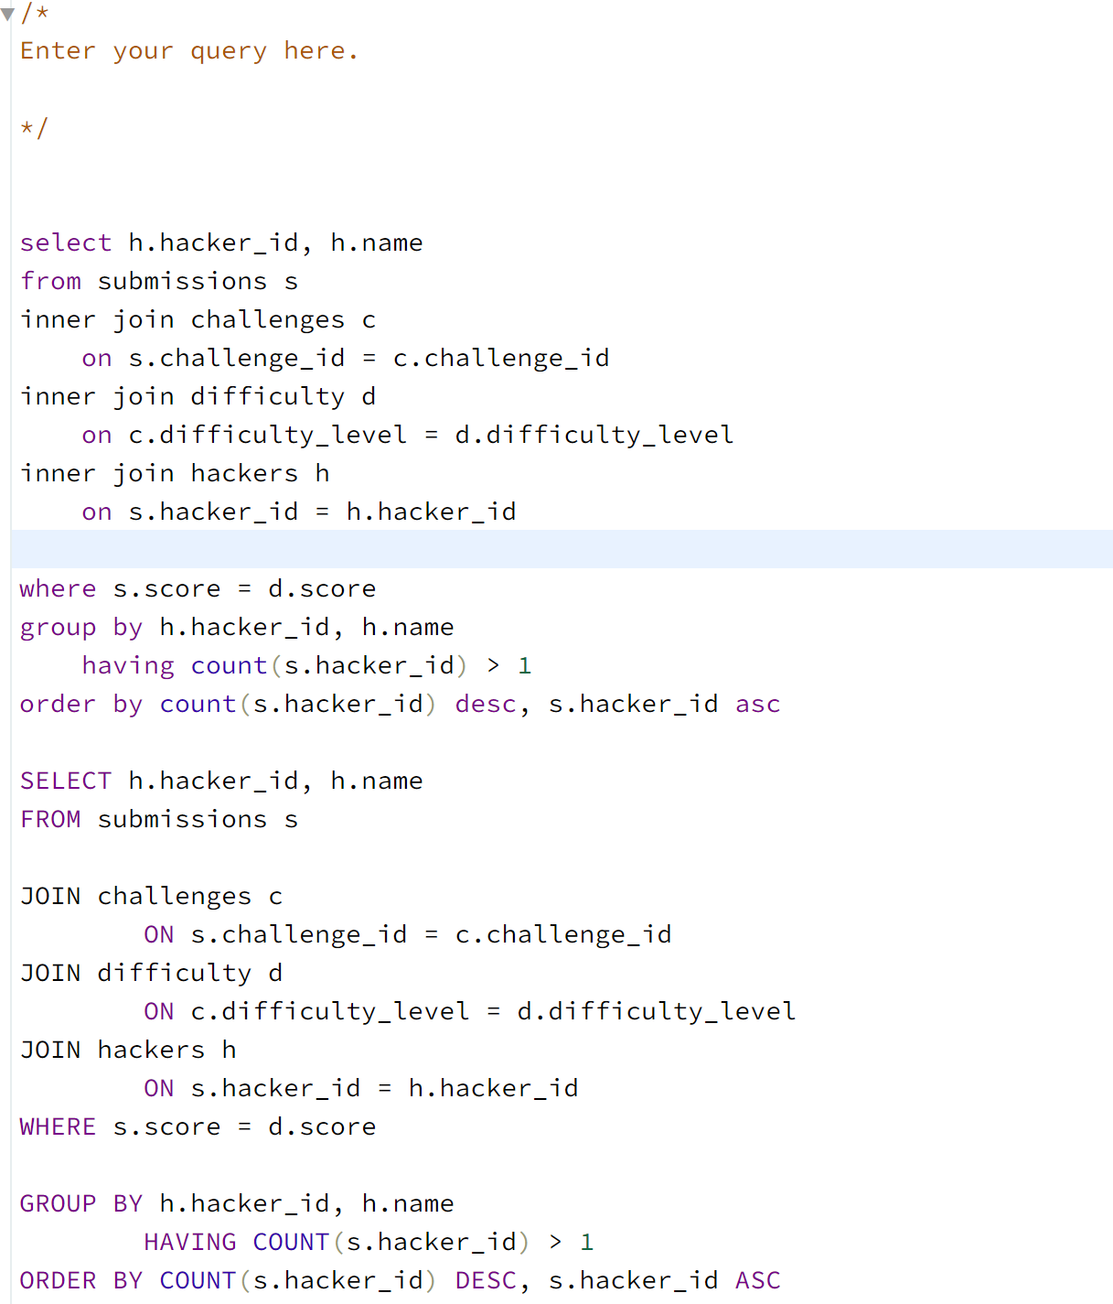

- https://www.hackerrank.com/challenges/harry-potter-and-wands/problem
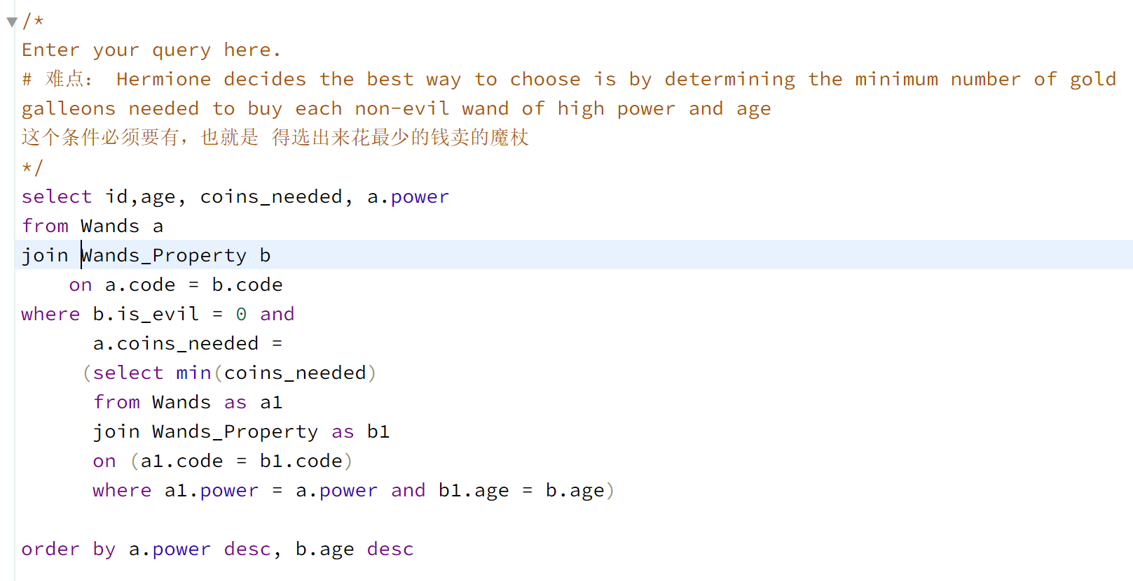
- 画三角形
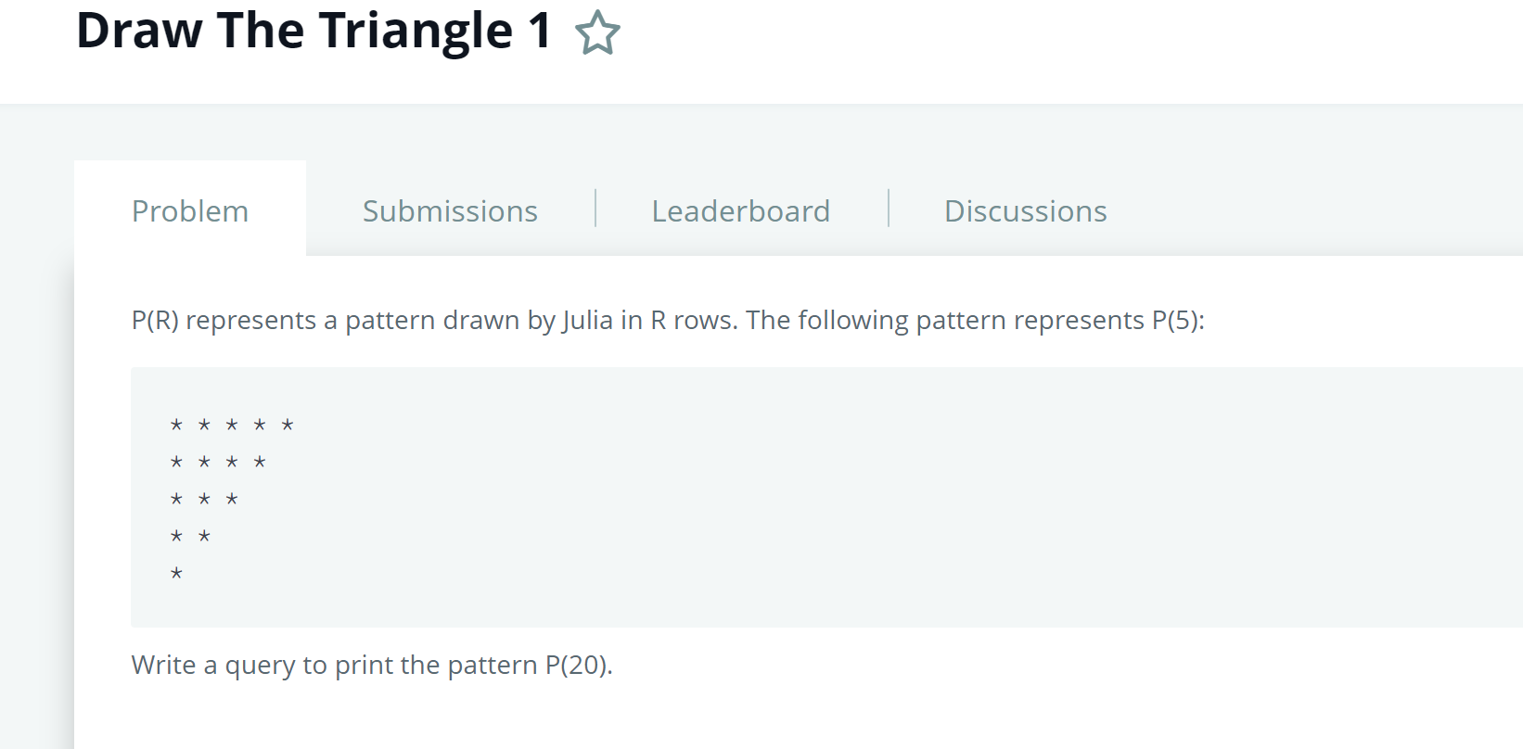
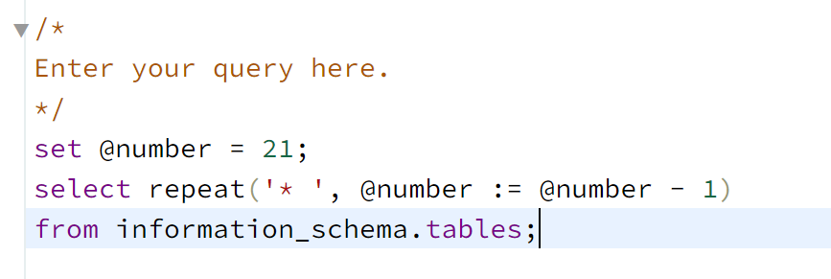
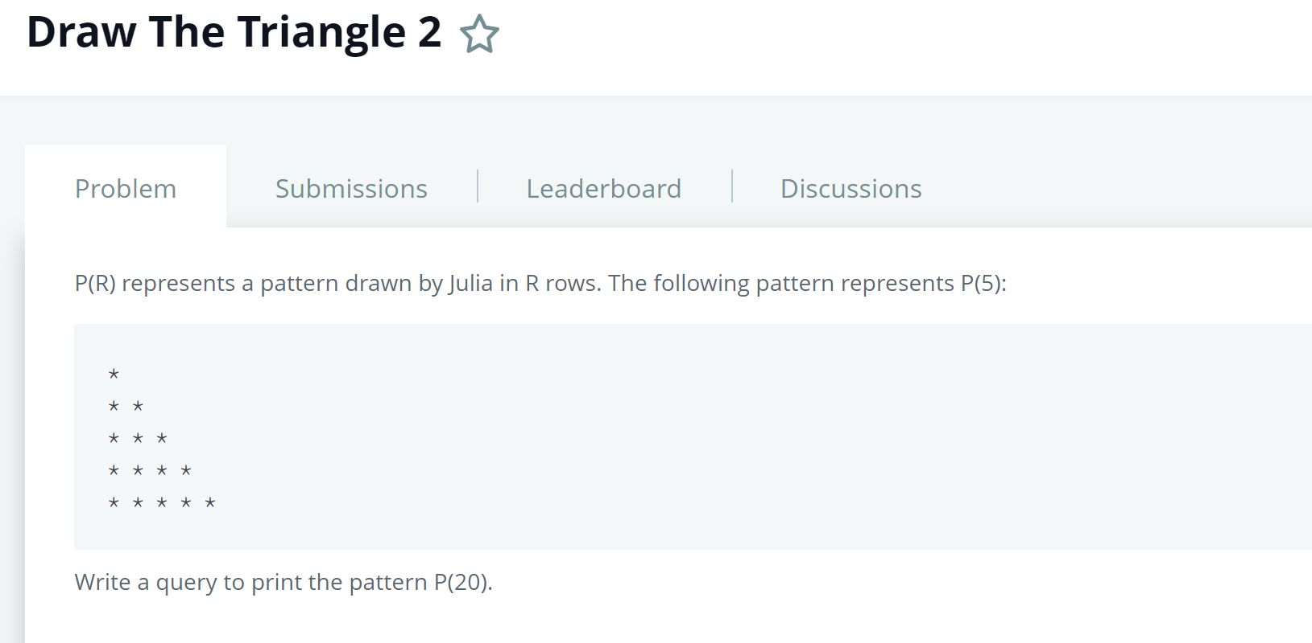
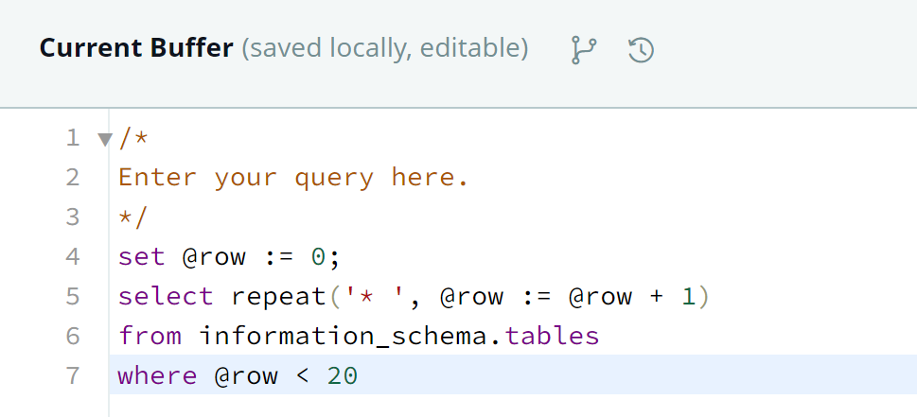
- Query the two cities in STATION with the shortest and longest CITY names, as well as their respective lengths (i.e.: number of characters in the name). If there is more than one smallest or largest city, choose the one that comes first when ordered alphabetically.
https://www.hackerrank.com/challenges/weather-observation-station-5/problem
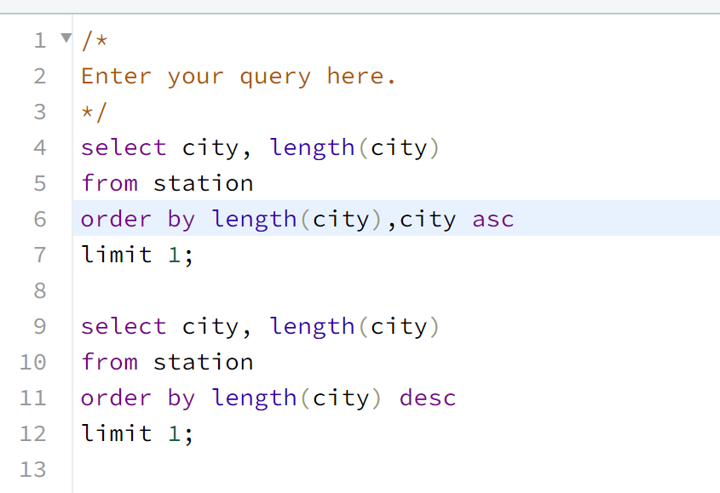
- 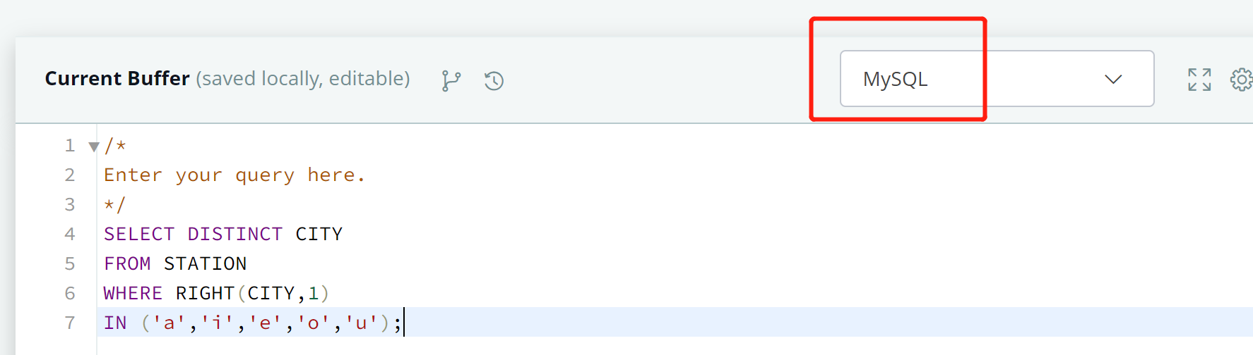
两种写法不一样， 注意区别
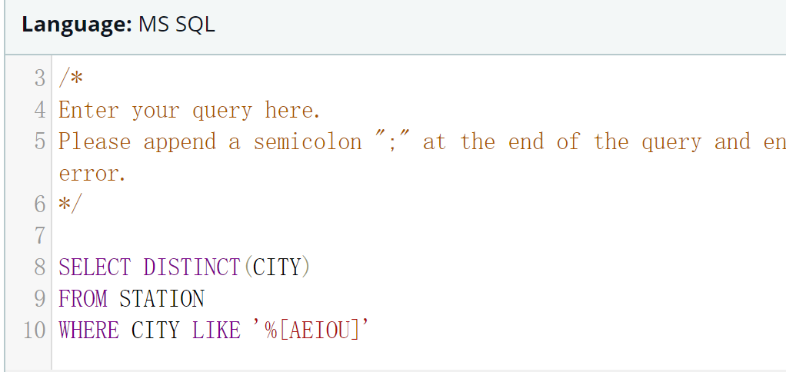

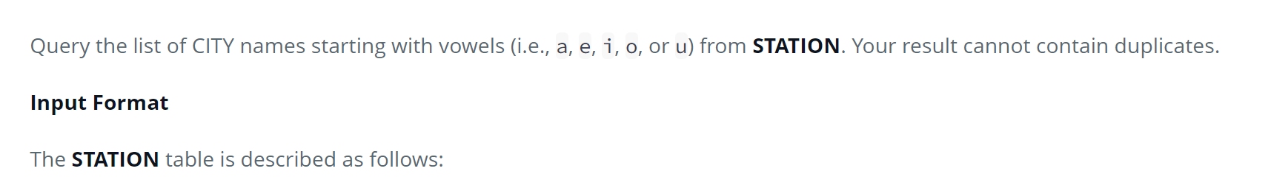
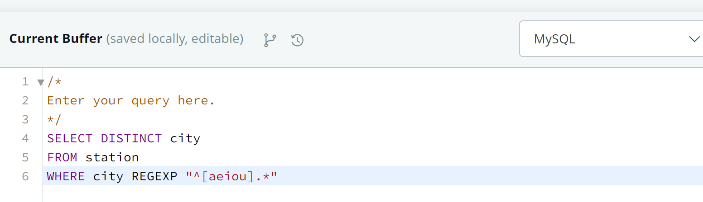
注意两种写法不一样，笔试的时候万一出问题，看看语言种类，mysql里面没有like 函数

